Reflection

Braydan Newman
n11272031

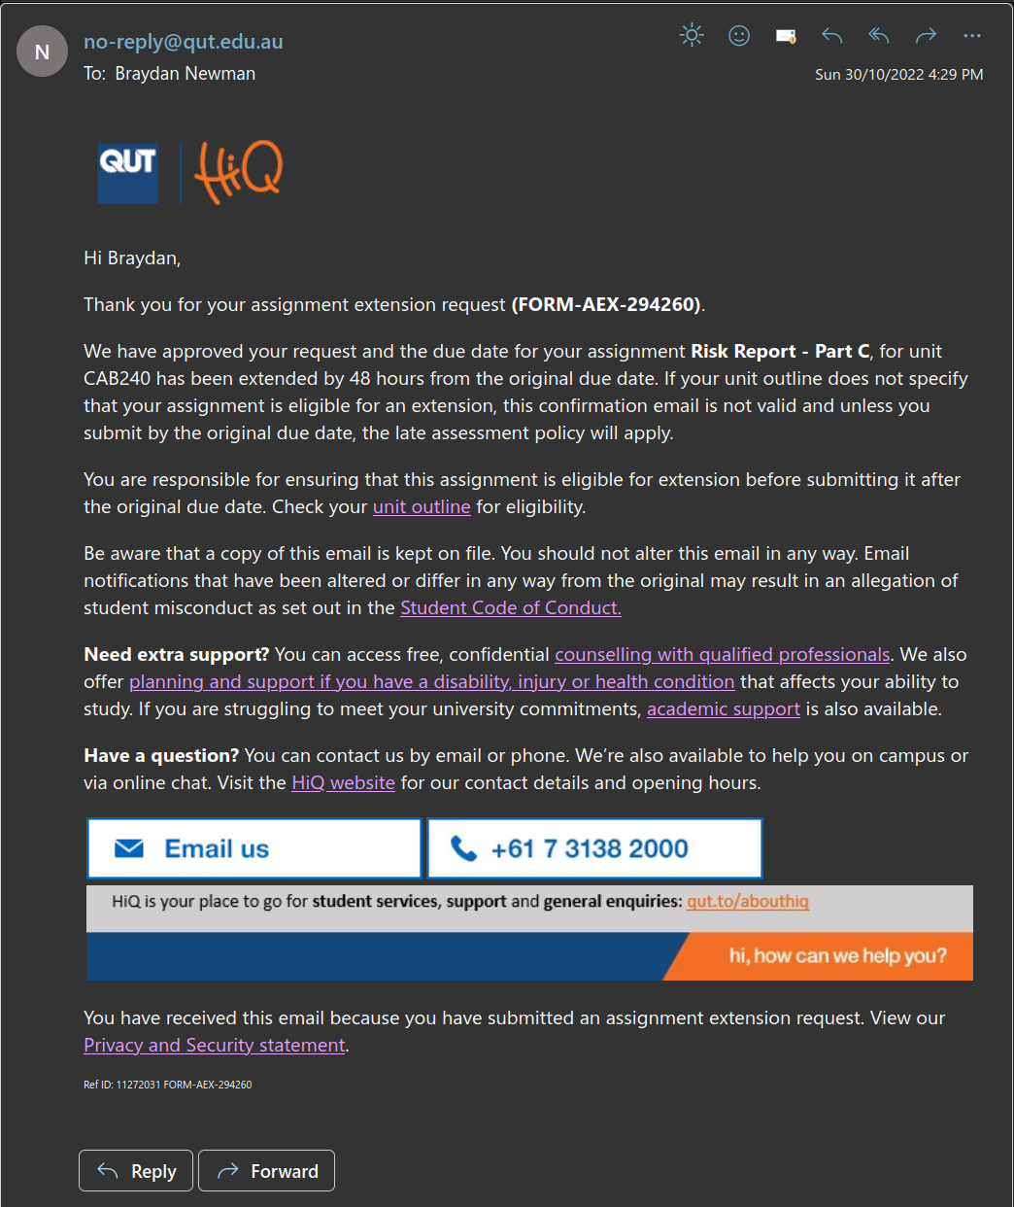

During the completion of the previous parts of this assessment, the team worked very well together with no disagreements, only discussions on the best course of action. In terms of everyone together meeting there were only a couple but there was constant communication over discord and text. This was plenty of communication to keep everyone on the same page. As far as team performance it was a solid effort from all team members, everyone worked cohesively together. Work was divided up by people just say I’ll do this part and no one ever had any issues. This all worked really well and made completing the assessment quite easy and painless. We definitely had a team lead that wasn't “elected” but more just rose as they were willing to put the time in to combined all parts from the team. This was worked really well for the team as they kept pushing us to get what we needed done and keep it coherent.

In terms of what didn't work well, there where very few if no issues through the entire process. My performance was lacking in the ability to write and make sure I had covered all points without while also going into depth, about the topics that needed to be covered. I was the weakest writer out of the team and need more reversion by other team members on my parts of the assessment. The only thing that might have made the team work better then we where was having all team members in the same class allowing us to have more group meetings, but this wasn't an issue and just a consideration of what might have worked better.

What I have learnt from this assessment and working in the team I did. My team members where great and learnt a bit from working with them. There was no way for me to play to my strengths in the assessment, as this was a pure research and writing task with no practical component, but the others seem to be very good at writing allowing us to get though we no issues. To help improve my effectiveness in the team I’d try and take on a practical roll if possible and if writing needs to be done, get it done quicker then the other to make it easier for them to double check my work.

